**Main Menu (Prototype 1)**

1.1 Main Menu

This menu would appear when the player has their hand **facing up**. The default would be the right hand, but they can change it in the **Settings menu**. The menu would go away when the player has their hand **facing down**.

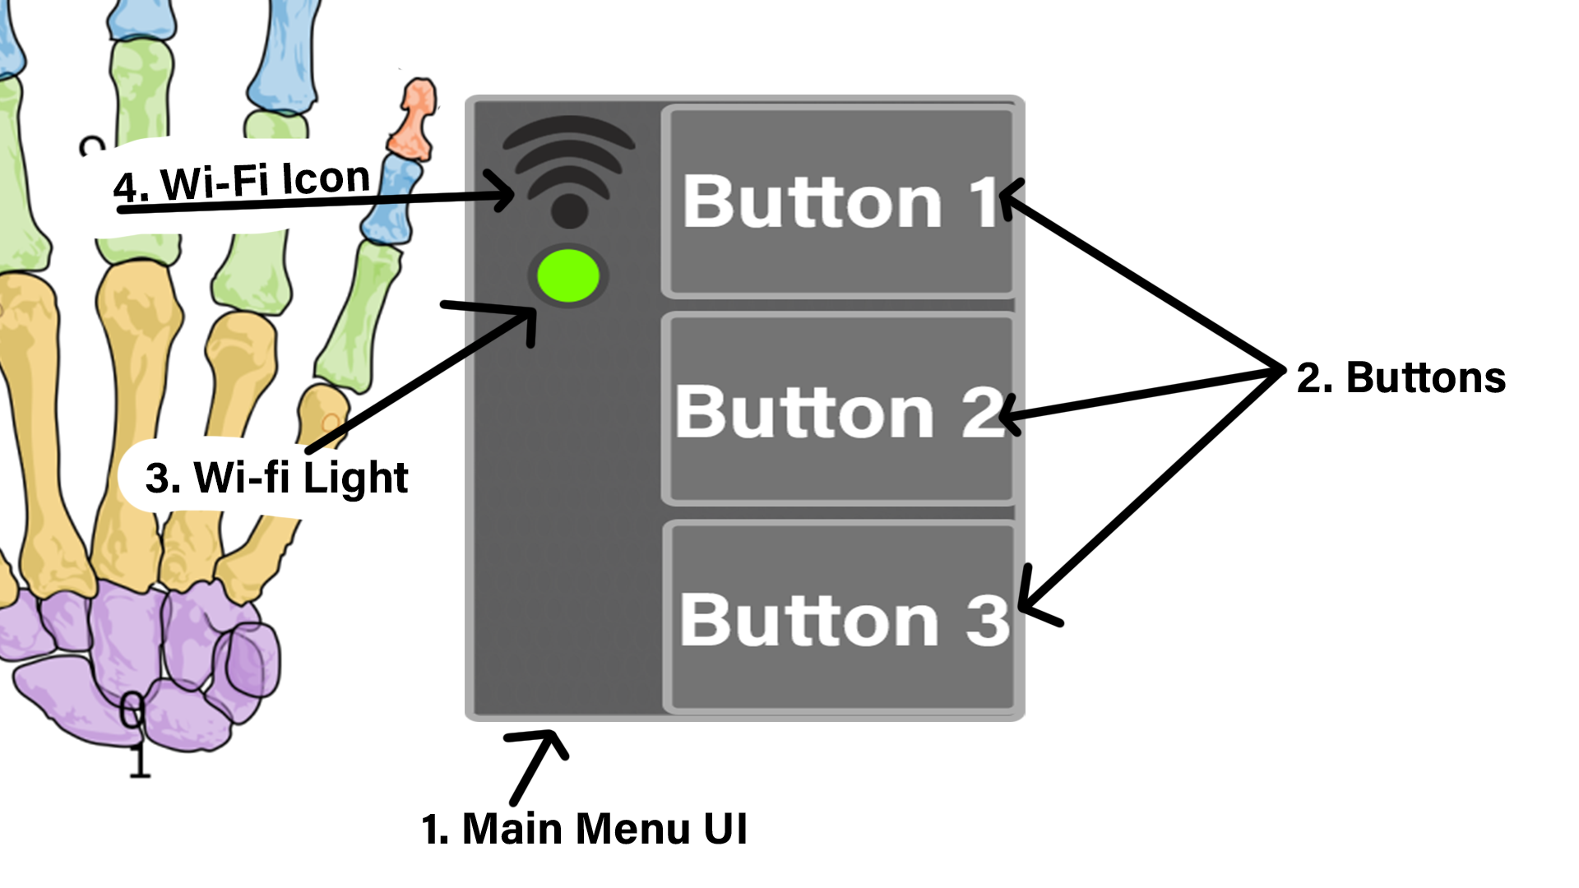

1. This is the overall template for the UI, where the Buttons (2) and other information would be located (like the Wi-Fi stuff). *The Wi-Fi icon is temporary and might be located somewhere else.*

2. The Buttons activate when the player presses the button UI. When pressed, it will **open up something (such as another tab)**. The button’s color will become brighter to indicate that it is open (Example).

Button 1 is brighter than the rest because it is active

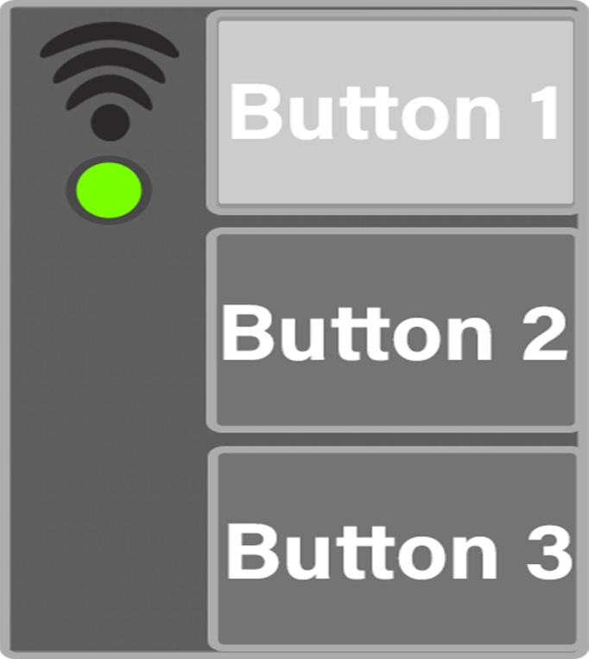

The player could **close the activated UI** from the Menu by tapping on the button they pressed to open. (For now Button 1 will open the **Settings UI**)

Note: I’ll send Settings UI menu stuff; I just want to send this as fast as possible.

3 and 4. The Wi-fi light will light up when the player is connected to the people back at base (NOTE: This doesn’t have to work right now. It’s just an icon to see if the placement looks good or not)